SESSION BEGIN: 6:02PM
SESSION ADJOURNED: 8:03PM
ATTENDEES: MINH MEDEIROS, MELISSA WILLIAMS, NICOLE SAVITSKI (CALL), DARCY KENNEDY (Call), MELANIE LADSEN, ALISA SPECKMANN
AGENDA
2022 SEASON
- REGISTRATION
Division Name | 94
2022 Mighty Mites Grades 1 | 17
2022 Mighty Mites Grades 2 | 26
2022 Mites Grades 3-4 | 17
2022 Peewees Grades 5-6 | 16
2022 Midgets Grades 7-8 | 18

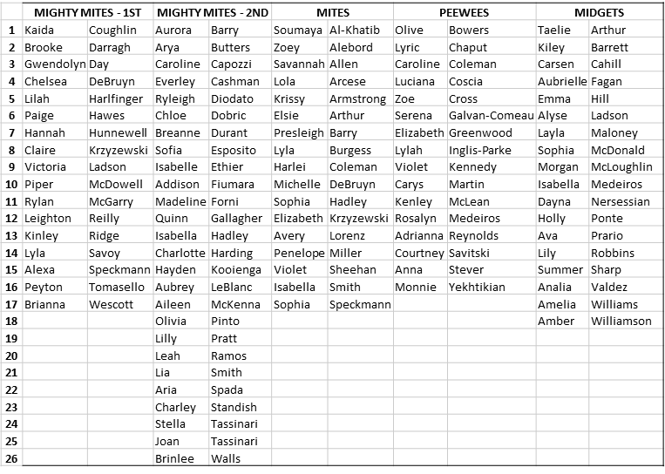
- UNIFORM TRY ON DATE – Saturday, May 21 early am
  - New uniforms are being designed, we are in the process and are working with Rebel & Varsity!
  - Rebel & Varsity Reps: 45-60 Days for production after they do prototype (4 weeks). They will send Kaytee the look books. Approve designs by end of March
  - Titan Sports - Jerseys roughly $35 – Nicole will confirm
    - Optional evening date – Confirm with Varsity Katie about a date
- COACHING
  - Jr. Coaches to be interviewed at Uniform Try Ons on May 21st Below are recommendations and not yet definite
  - Set up a coach meeting for all new coaches
  - MIGHTY MITES 1st (17)
    - Head Coach: Darcy Kennedy
    - Assistant Coach:
      - Stefanie Wescott (Brianna Wescott)
      - Darcie Bastis (Peyton Tomasello)
    - Junior Coach:
      - Ariana Lennox
  - MIGHTY MITES 2nd (26)
    - Head Coach: Tayla Murphy (Isabella Ethier)?
    - Assistant Coach:
      - Charlene Standish (Charley Standish)
    - Junior Coach:
      - Emma Brand
      - Amora Mitchell
      - Grace Ladson
  - MITES (17)
    - Head Coach: Michelle Hurley
    - Assistant Coach:
    - Junior Coach:
      - Alice Rose?
      - Juliana Gilcoine
      - Sawyer Heinrich
  - PEEWEES (16)
    - Head Coach: Sarah Crockett
    - Assistant Coach: None Needed
      - Erika Laing – Signed Up – notify that they are not needed
      - Kelly Stever – Signed Up – notify that they are not needed
    - Junior Coach:
      - Kayleigh Savitski
      - Allie Gillis
      - Sophie Henley
  - MIDGETS (18)
    - Head Coach: Terri Ashby Crudup
    - Assistant Coach: Hailey Crudup
    - Junior Coach:
      - Addison Morin
      - Cloe Geraigery (Not Signed Up)
      - Abby Batchelor
      - Kat Mooney (Not Signed Up)

  - CHOREOGRAPHY: SAVE THE DATE August Choreography!
    - Mites: 8/18-8/19
    - Peewees/Midgets: 8/20-8/21
    - Full House in West Bridgewater
  - TUMBLING
    - Tumbling class will continue to be offered at CFAS from June-July for SLYC.
- COMPETITION: Silver Lake Youth Cheerleading participates in up to four (4) competitions during the season (typically end of October to Mid-November).
- NECD – Saturday, November 5th
- East Coast Showdown – Saturday, November 12th
- OCYCA – Saturday, November 19th – By the time indoor practice start we will decide if 2nd graders will do expedition
  - CONCUSSION TRAINING - All coaches, board members & team moms.
    - This is online – Must be completed before first practice in August
    - SLYC to pay

- UNIFORM TRY ON – Saturday, 5/21 Faunce Building
  - Katie from Varsity will measure
    - Ask if she can do a Friday Evening Try On as well
  - Break the day out by Teams
  - Meet/Interview Jr. Coaches
  - Ask if anyone wants to volunteer to be Team Mom

- SCHOLARSHIPS – Review and Choose Recipients (4 Applications) – June 2nd Award Night
  - Winners: 2 Winners Selected
    - $500 Each. Darcy to hand out at Awards Ceremony

- TREASURER REPORT
  - $31, 411.33 In Bank Account, Venmo: $472
    - Let’s close the Safety Deposit Box at the bank
  - Scratch Ticket Raffle $160
  - Registration Funds:
    - Collected: $20,850.00
    - Outstanding: $10,551.00 due July 1^{st –} Send out Reminder the week before
  - What do we want to do with the rest of the money?
    - Uniforms, Shed, Mats…etc
      - Alisa to follow up about KYSO Shed

- FUNDRAISING
  - SNAP Campaign
- Mel to create a flier to be handed out at Uniform Try On
  - Write check for $150 – If you do not participate, we will cash your check
  - Joint Football/Cheer Fundraisers
- OCYCA MEETING – Updated Rubric – Next Meeting is First Wednesday in August

- PICTURE DAY Look into scheduling dates for September, must make sure we have uniforms

COMMUNICATION
- INTRODUCTIONS
  - OCYCA – Letter written to introduce new board, Val to provide address
  - First Practice in August will be an athlete/parents/coach/board meet & greet. Set all the rules/guidelines/expectations for the season.
  - Parent/Coach Survey
    - Communication via App
    - FB will be kept open for General updates and photos
  - Communication (FB, Email, Sports App) –
    - Need to set up FB Pages for Mighty Mites Teams
    - Part of survey to determine which is best method. Team Moms will be primary source of updates to each team. They will work closely with the Coaches. Monthly Newsletter/Board Recaps sent out by President for topline important information.

BYLAWS REVIEW/UPDATE – Need to set up a separate meeting to finalize
OLD JOB DESCRIPTION: Board to Review and Update
- PRESIDENT: Assumes full responsibility for the operation of the organization, responsible for registration, banquet, and uniforms
- VP: Shall act in the absence of the President, serve as Volunteer Coordinator, spearhead SLYC Fundraising activities, scholarship chairperson, SLYC Representative to OCYCA
- Secretary: Keep the minutes of all the meetings, works with President on uniform fittings and ordering, confirms all field and gym space, maintains current membership list, coordinates tumbling clinics
- Treasurer: Custodia of all funds, keeps detailed books, prepares budgets and monthly reports
- Coach/Safety Coordinator: Acts as the primary SLYC representative to the OCYCA Board and attends all OCYCA meetings, coordinates competitions (Logistics, registration, waivers, transportation and parent communication)
- Updated bylaws through executive board duties
- Changed around job descriptions for board
- Adding fundraising head (fundraising committee & scholarship committee)
- Concussion certification for coaches, board, and team moms
- Once these are fully read through and finished, the board will post the updated version

BOARD MEETING DATES – 1st Thursday of the Month
Thank you to all who donated time & resources at the KYSO fun day!

- NEXT MEETING WILL BE Thursday, June 2nd. Board Meeting 6-8pm Reed Lower Level, ALL ARE WELCOME

PRESIDENT | MINH MEDEIROS | SLYCPRESIDENT@GMAIL.COM | 508.649.3599
VICE PRESIDENT | MELISSA WILLIAMS | SLYCVP@GMAIL.COM | 508.718.8646
TREASURER | DARCY KENNEDY | SLYCHEERTREASURER@GMAIL.COM | 781.760.4046
SECRETARY | KAYTEE MCLEAN | SLYCHEERSECRETARY@GMAIL.COM | 774.269.1629
COACH COORDINATOR | NICOLE SAVITSKI | SLYCCOACHCOORDINATOR@GMAIL.COM | 781.706.7864
OCYCA REP | VAL WARWICK | GRAMMYVAL01862@COMCAST.NET | 617.462.4307
FUNDRAISING COORDINATOR | MELANIE LADSEN | SLYCFUNDRAISING@GMAIL.COM | 781.635.9126
SLYC KYSO REP | ALISA SPECKMANN | SLYC.KYSO@GMAIL.COM | 617.755.9196

